**LAB # 02**

**ArrayList and Vector in JAVA**

**OBJECTIVE:** To implement ArrayList and Vector.

# Question 1:

# Write a program that initializes Vector with 10 integers in it. Display all the integers

# and sum of these integers.INPUT:

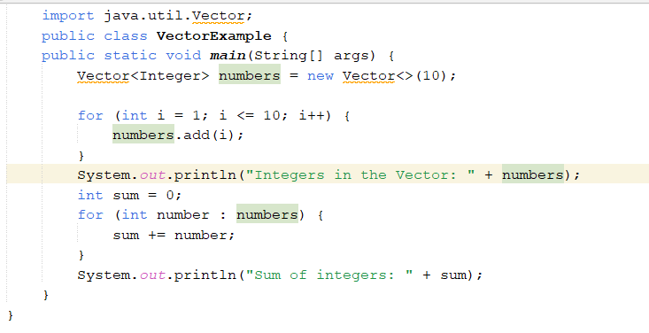

**OUTPUT:**



# Question 2:

Create a ArrayList of string. Write a menu driven program which: a. Displays all the elements b. Displays the largest String

# INPUT:

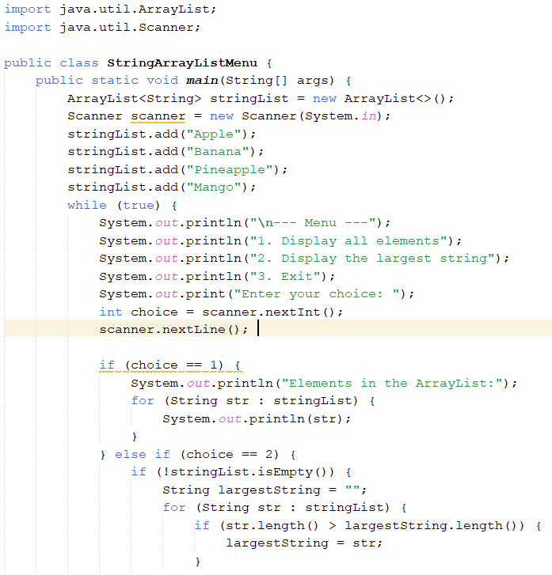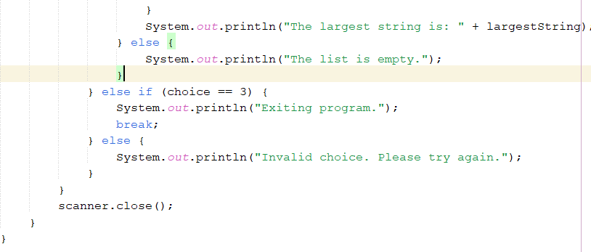

**OUTPUT:**

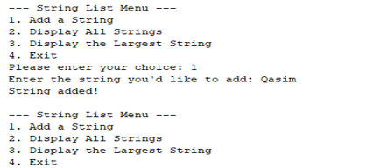

# Question 3:

Create a Arraylist storing Employee details including Emp_id, Emp_Name, Emp_gender, Year_of_Joining (you can also add more attributes including these). Then sort the employees according to their joining year using Comparator and Comparable interfaces.

**INPUT:**

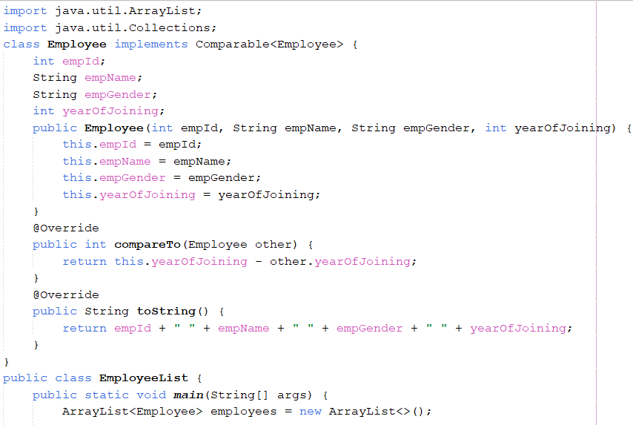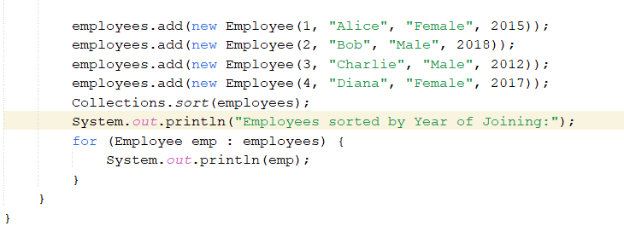

**OUTPUT:**

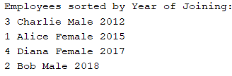

# Question 4:

Write a Java program to find the minimum and maximum values of Integer, Float, and Double using the respective wrapper class constants.

# INPUT:

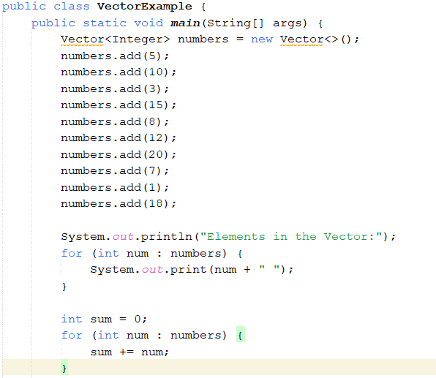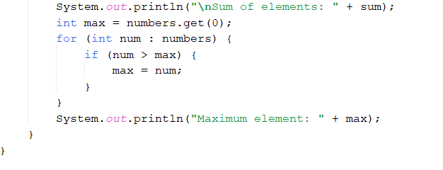

**OUTPUT:**

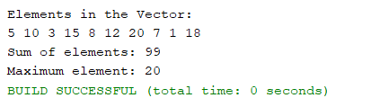

# Question 5:

# Find the k-th smallest element in a sorted ArrayList

# INPUT:

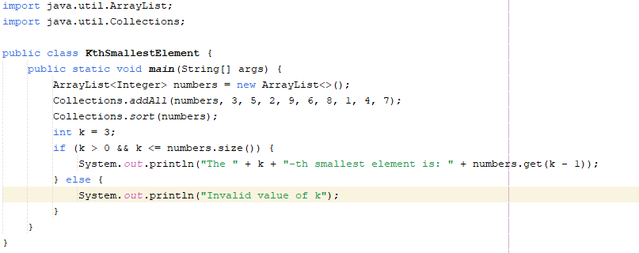

**OUTPUT:**

# 

# Question 6:

# Write a program to merge two ArrayLists into one

# INPUT:

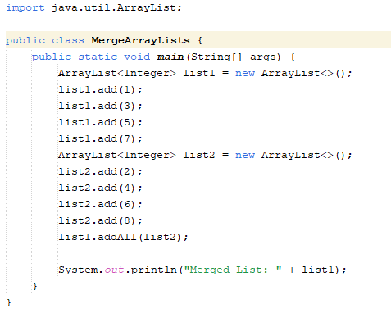

**OUTPUT:**



**HOME TASKS**

**Question 1:**

# Create a Vector storing integer objects as an input. a. Sort the vector b. Display largest number c. Display smallest number

# INPUT:

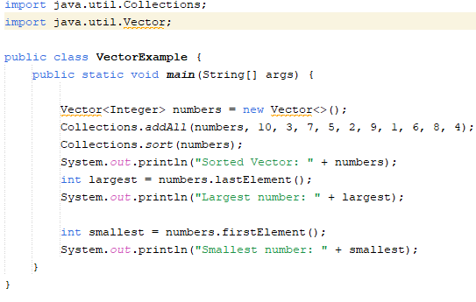

**OUTPUT:**

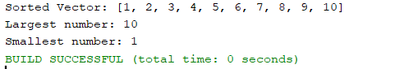

# Write a java program which takes user input and gives hashcode value of those inputs using hashCode () method.

# INPUT:



**OUTPUT:**



Question 2:

# Create a Color class that has red, green, and blue values. Two colors are considered equal if their RGB values are the same

# INPUT:

**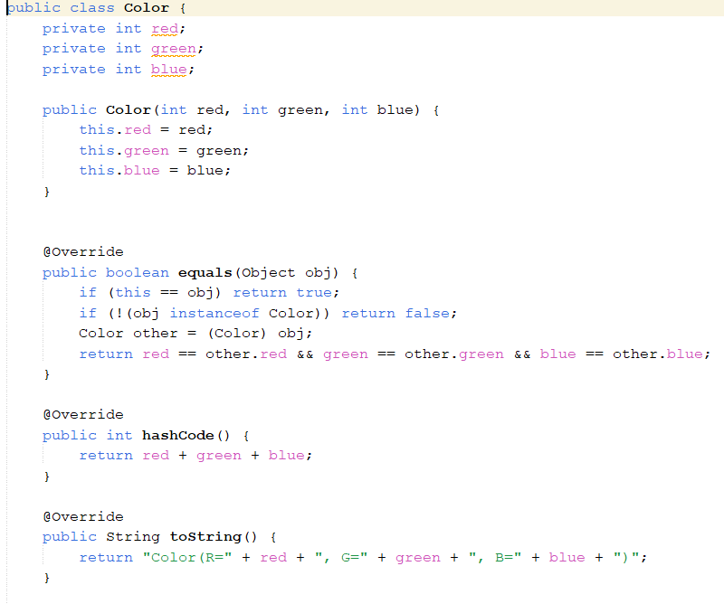  
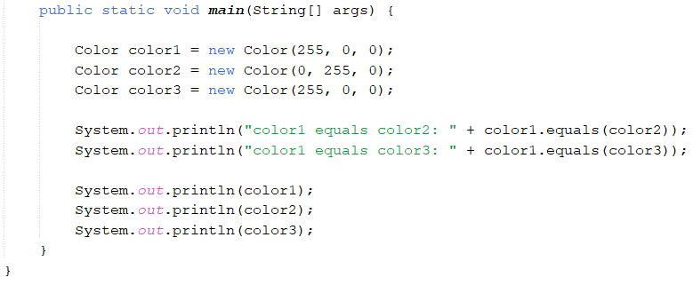**

**OUTPUT:**

